To Design Parser Logic, Generate Parse Trees, Validate Syntax, Detect Errors, Handle Empty Commands, Produce Execution Structures

Code:
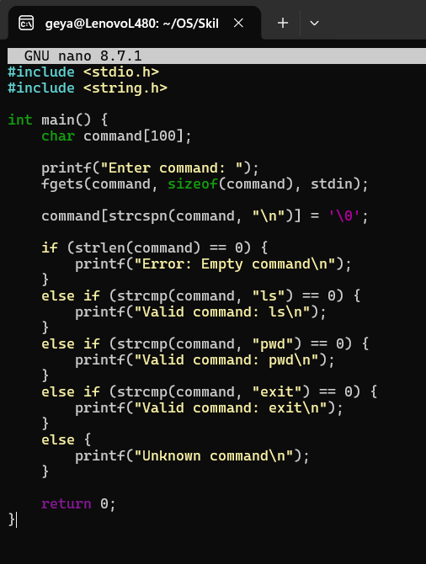

Output:
